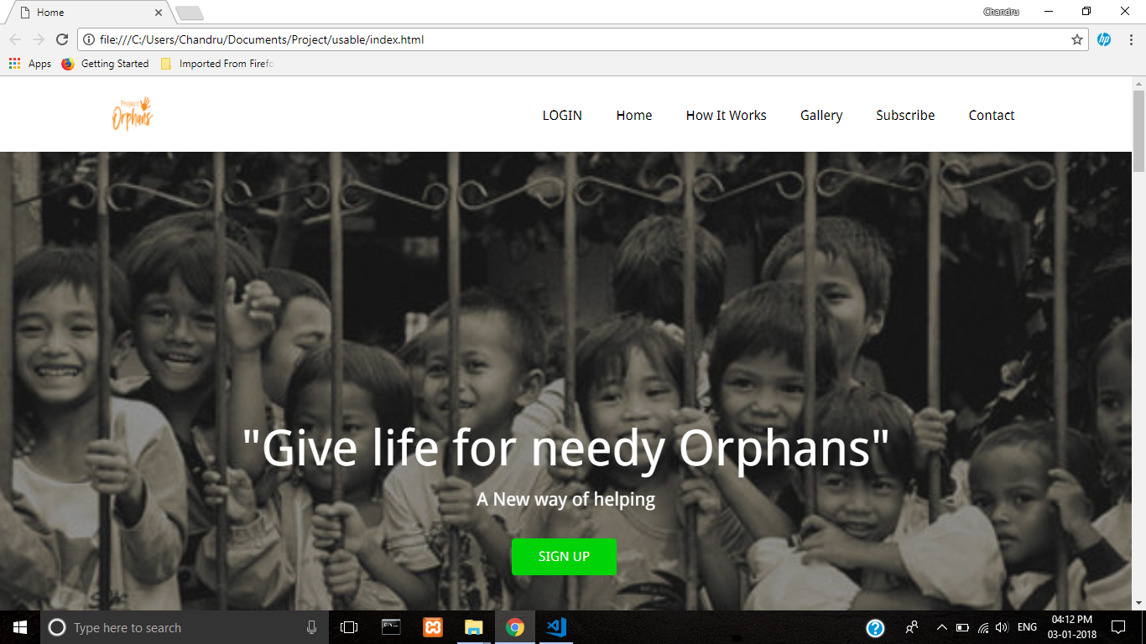

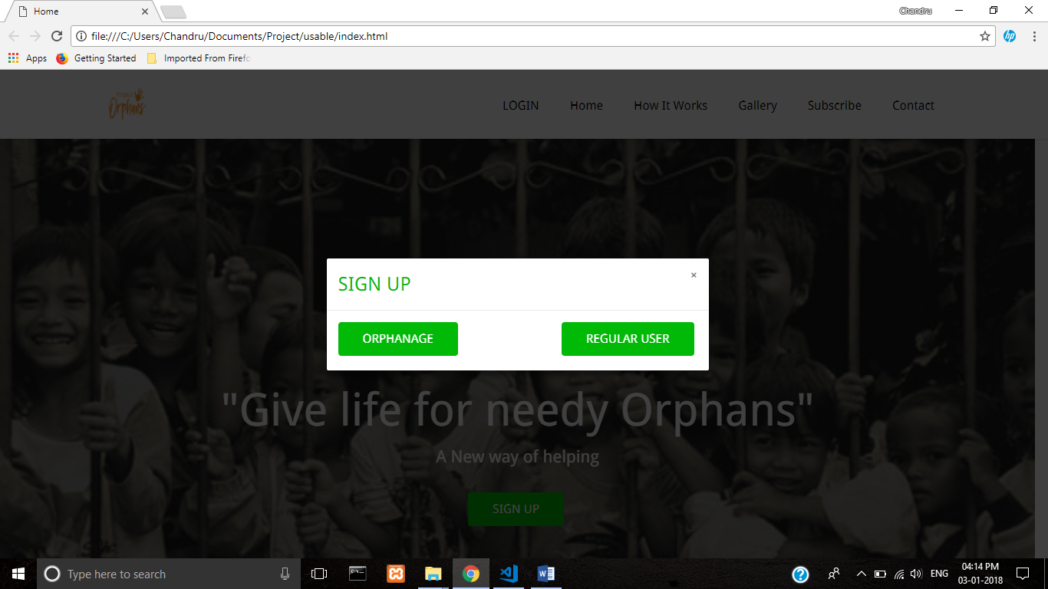

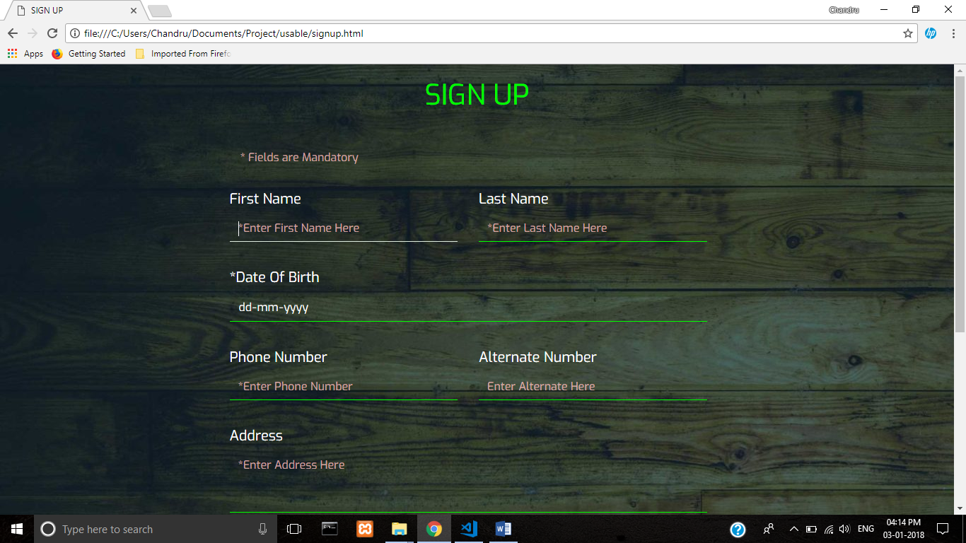

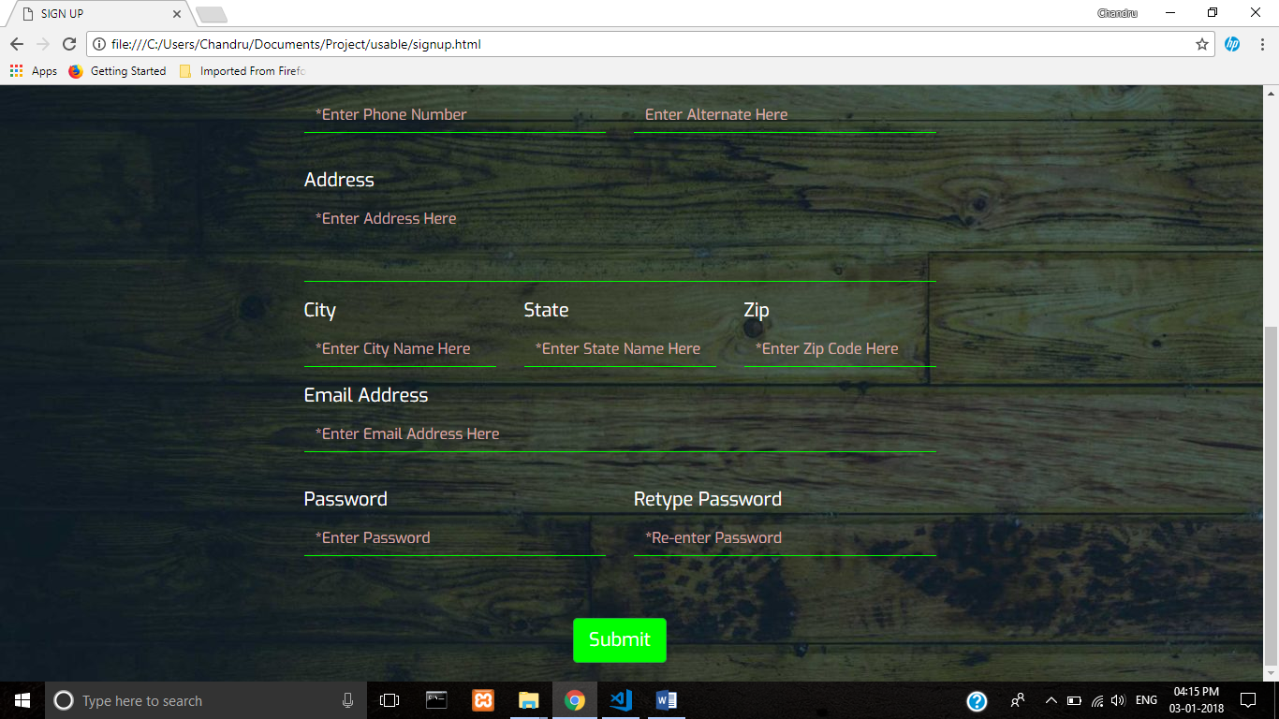

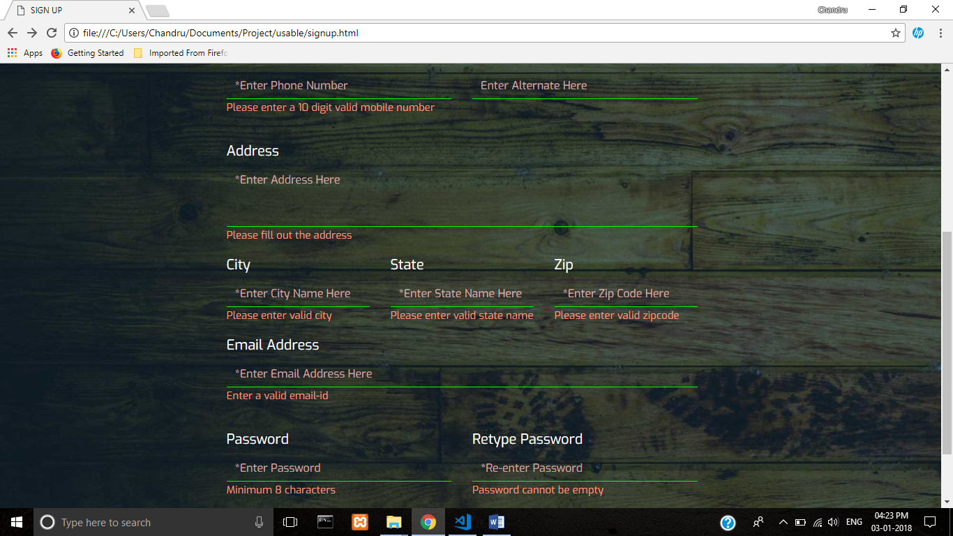

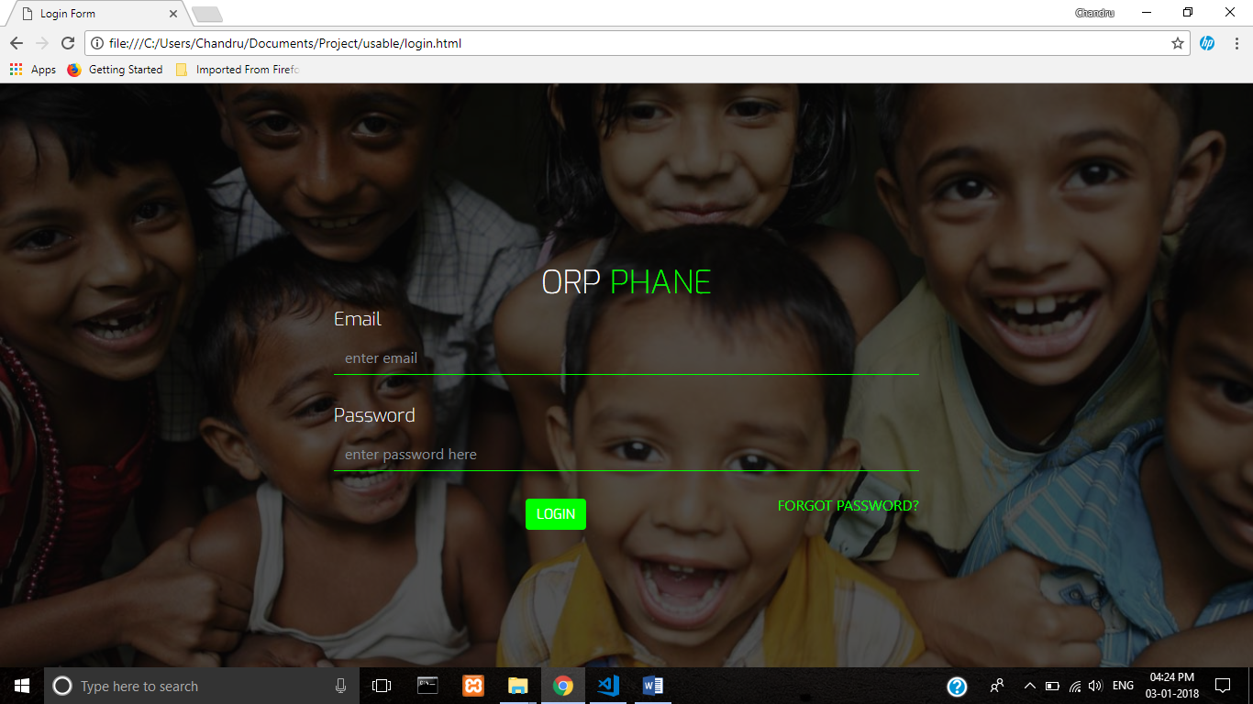

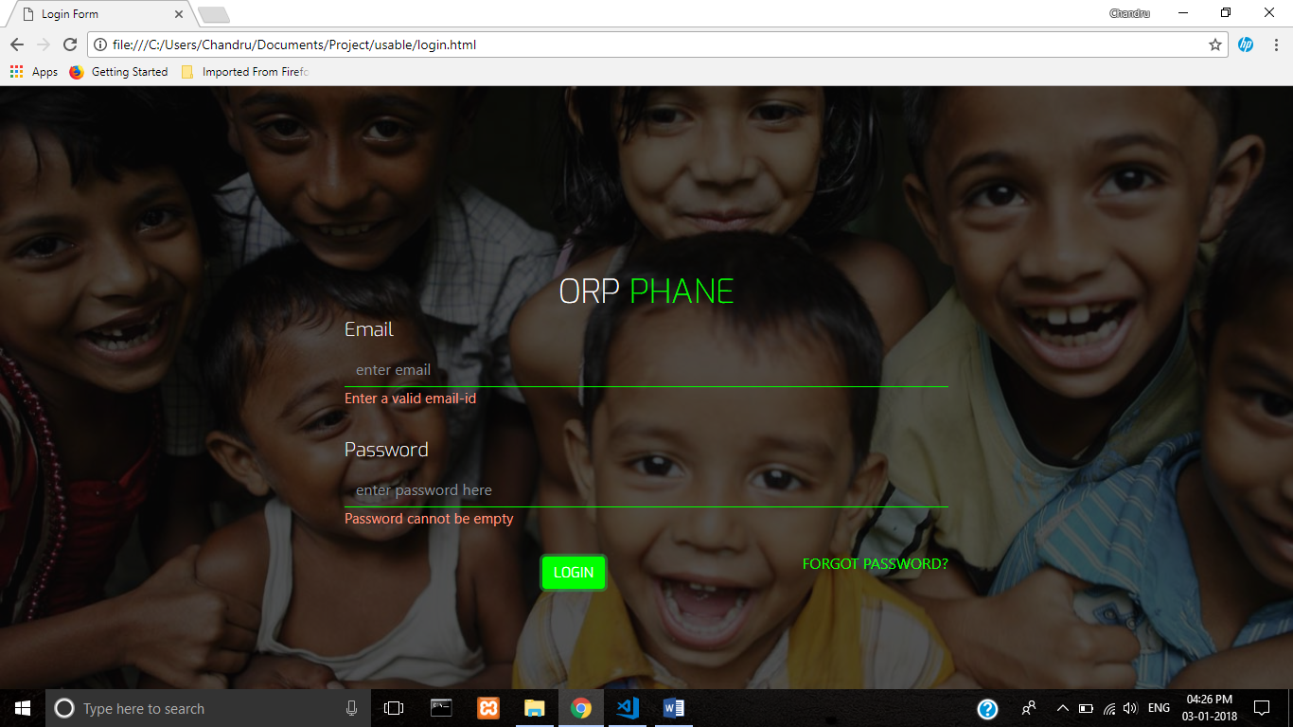

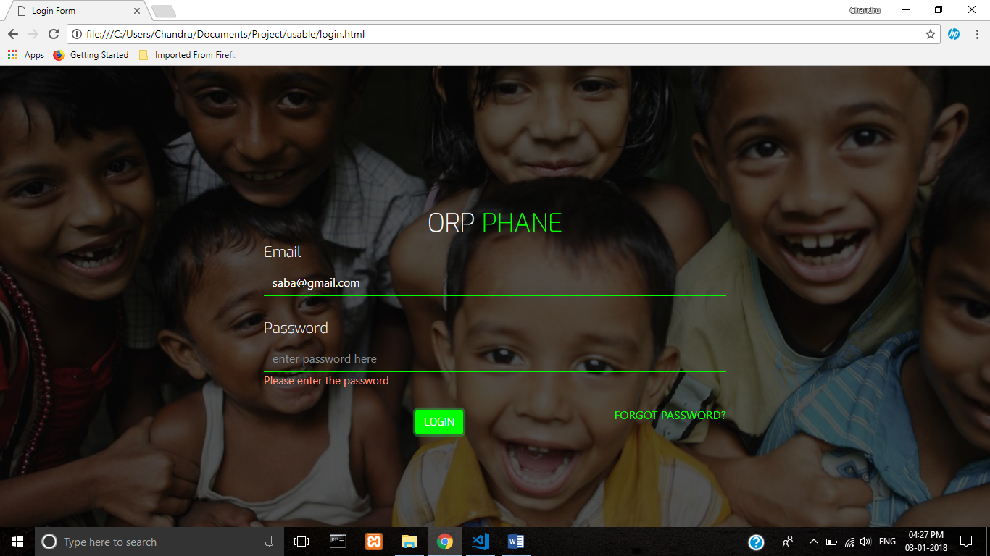

**Main.js**

var userError = ["Enter a valid email-id", "Enter a valid first-name", "Enter a valid last-name"];

var passError = ["Password cannot be empty", "Please enter the password", "Password mismatch", "Minimum 8 characters"];

var phoneNumberError = ["Please enter a 10 digit valid mobile number", "Alternate number is same as primary"];

var addressError = ["Please fill out the address", "Please enter valid city", "Please enter valid state name", " Please enter valid zipcode"];

var nameReg = /^[a-zA-Z]+$/;

var emailRegex = /^(([^<>()\[\]\\.,;:\s@"]+(\.[^<>()\[\]\\.,;:\s@"]+)*)|(".+"))@((\[[0-9]{1,3}\.[0-9]{1,3}\.[0-9]{1,3}\.[0-9]{1,3}\])|(([a-zA-Z\-0-9]+\.)+[a-zA-Z]{2,}))$/;

var phoneRegex = /^[0-9]{10}$/;

var addRegex = /^[0-9a-z A-Z-,'/ / ]+$/;

var zipRegex = /^[0-9]{6}$/;

function login() {

location.href = "login.html";

}

function getValue(idName) {

return document.getElementById(idName).value.trim();

}

function dispError(idName, arrName, index) {

//console.log(idName);

document.getElementById(idName).innerHTML = arrName[index];

}

function validateLogin() {

var status = false;

var username = getValue("user-email");

var password = getValue("user-password");

(checkEmail(username) === false) ? dispError("username-error", userError, 0): status = false;

// alert("UserName Cannot be Empty");

(checkField(password) === false) ? dispError("password-error", passError, 0): status = false;

//alert("Password cannot be Empty");

(checkEmail(username) === true && checkField(password) === false) ? dispError("password-error", passError, 1): status = false;

if (checkEmail(username) && checkField(password)) {

status = true;

}

return status;

}

function checkDetails() {

var firstName = getValue("firstName");

var lastName = getValue("lastName");

var phoneNumber = getValue("phoneNumber");

var altNumber = getValue("altNumber");

var address = getValue("address");

var city = getValue("city");

var state = getValue("state");

var zip = getValue("zip");

var emailId = getValue("emailId");

var pass = getValue("pass");

var checkPass = getValue("checkPass");

var count = 0;

var flag = 0;

(checkName(firstName) === false) ? dispError("fname-error", userError, 1): count++;

(checkName(lastName) === false) ? dispError("lname-error", userError, 2): count++;

(checkPhoneNumber(phoneNumber) === false) ? dispError("number-error", phoneNumberError, 0): count++;

if (altNumber !== null && altNumber !== "") {

(checkPhoneNumber(altNumber) === false) ? dispError("altnum-error", phoneNumberError, 0): flag = 1;

count++;

}

if (phoneNumber === altNumber && (phoneNumber !== "" && phoneNumber !== null) && (altNumber !== "" && altNumber !== null)) {

dispError("number-error", phoneNumberError, 1);

dispError("altnum-error", phoneNumberError, 1);

}

(checkAddress(address) === false) ? dispError("address-error", addressError, 0): count++;

(checkName(city) === false) ? dispError("city-error", addressError, 1): count++;

(checkName(state) === false) ? dispError("state-error", addressError, 2): count++;

(checkZip(zip) === false) ? dispError("zip-error", addressError, 3): count++;

(checkEmail(emailId) === false) ? dispError("email-error", userError, 0): count++;

(checkField(pass) === false) ? dispError("pass-error", passError, 0): count++;

(checkField(checkPass) === false) ? dispError("checkpass-error", passError, 0): count++;

(checkPasswordLength(pass) === false) ? dispError("pass-error", passError, 3): count++;

if (checkField(pass) && checkField(checkPass) && pass !== checkPass) {

dispError("pass-error", passError, 2);

dispError("checkpass-error", passError, 2);

count -= 2;

} else {

count++;

}

if ((flag === 1 && count === 13) || (flag === 0 && count === 12)) {

return true;

}

return false;

}

function checkEmail(email) {

return emailRegex.test(email);

}

function checkPhoneNumber(no) {

return phoneRegex.test(no);

}

function checkName(name) {

return nameReg.test(name);

}

function checkAddress(address) {

return addRegex.test(address);

}

function checkZip(zipcode) {

return zipRegex.test(zipcode);

}

function checkField(value) {

if (value === "" || value === null) {

return false;

} else {

return true;

}

}

function checkPasswordLength(value) {

if (value.length < 8) {

return false;

}

return true;

}

function togglePassword() {

var check = document.getElementById("inputPassword").checked;

//console.log(check)

if (check === true) {

document.getElementById("password-check").setAttribute('type', 'text');

} else {

document.getElementById("password-check").setAttribute('type', 'password');

}

}

function clearError(idName) {

//console.log(temp);

switch (idName) {

case "username-error":

case "password-error":

case "fname-error":

case "lname-error":

case "number-error":

case "altnum-error":

case "address-error":

case "city-error":

case "state-error":

case "zip-error":

case "email-error":

case "pass-error":

case "checkpass-error":

document.getElementById(idName).innerHTML = "";

break;

}

}

/*onkeyup functions*/

function validatePhoneNumber() {

var x = document.getElementById("phoneNumber");

if (!(/^[0-9]+$/.test(x.value))) {

x.value = x.value.slice(0, x.value.length - 1);

}

}

function validateAlternatePhoneNumber() {

var x = document.getElementById("altNumber");

if (!(/^[0-9]+$/.test(x.value))) {

x.value = x.value.slice(0, x.value.length - 1);

}

}

function firstNameLength() {

var x = document.getElementById('firstName');

if (x.value.length > 30) {

x.value = x.value.slice(0, x.value.length - 1);

document.getElementById('fname-error').innerHTML = 'Maximum 30 Characters';

} else {

document.getElementById('fname-error').innerHTML = '';

}

}

function lastNameLength() {

var x = document.getElementById('lastName');

if (x.value.length > 30) {

x.value = x.value.slice(0, x.value.length - 1);

document.getElementById('lname-error').innerHTML = 'Maximum 30 Characters';

} else {

document.getElementById('lname-error').innerHTML = '';

}

}

function addressLength() {

var x = document.getElementById('address');

if (x.value.length > 255) {

x.value = x.value.slice(0, x.value.length - 1);

document.getElementById('address-error').innerHTML = 'Maximum 255 Characters';

} else {

document.getElementById('address-error').innerHTML = '';

}

}

function cityLength() {

var x = document.getElementById('city');

if (x.value.length > 15) {

x.value = x.value.slice(0, x.value.length - 1);

document.getElementById('city-error').innerHTML = 'Maximum 15 Characters';

} else {

document.getElementById('city-error').innerHTML = '';

}

}

function stateLength() {

var x = document.getElementById('state');

if (x.value.length > 15) {

x.value = x.value.slice(0, x.value.length - 1);

document.getElementById('state-error').innerHTML = 'Maximum 15 Characters';

} else {

document.getElementById('state-error').innerHTML = '';

}

}